Ideation Phase

Empathize & Discover
Date | 13 July 2026
Team ID | SWTID-2026-8803
Project Name | Book Doctor Management System
Maximum Marks | 4 Marks

Empathy Map Canvas
An empathy map is a simple, easy-to-digest visual that captures knowledge about a user's behaviors and attitudes. It is a useful tool that helps teams better understand their users.
Creating an effective solution requires understanding the true problem and the person experiencing it. The exercise below considers the Book Doctor Management System from the perspective of a patient trying to book a doctor's appointment, along with her goals and challenges.
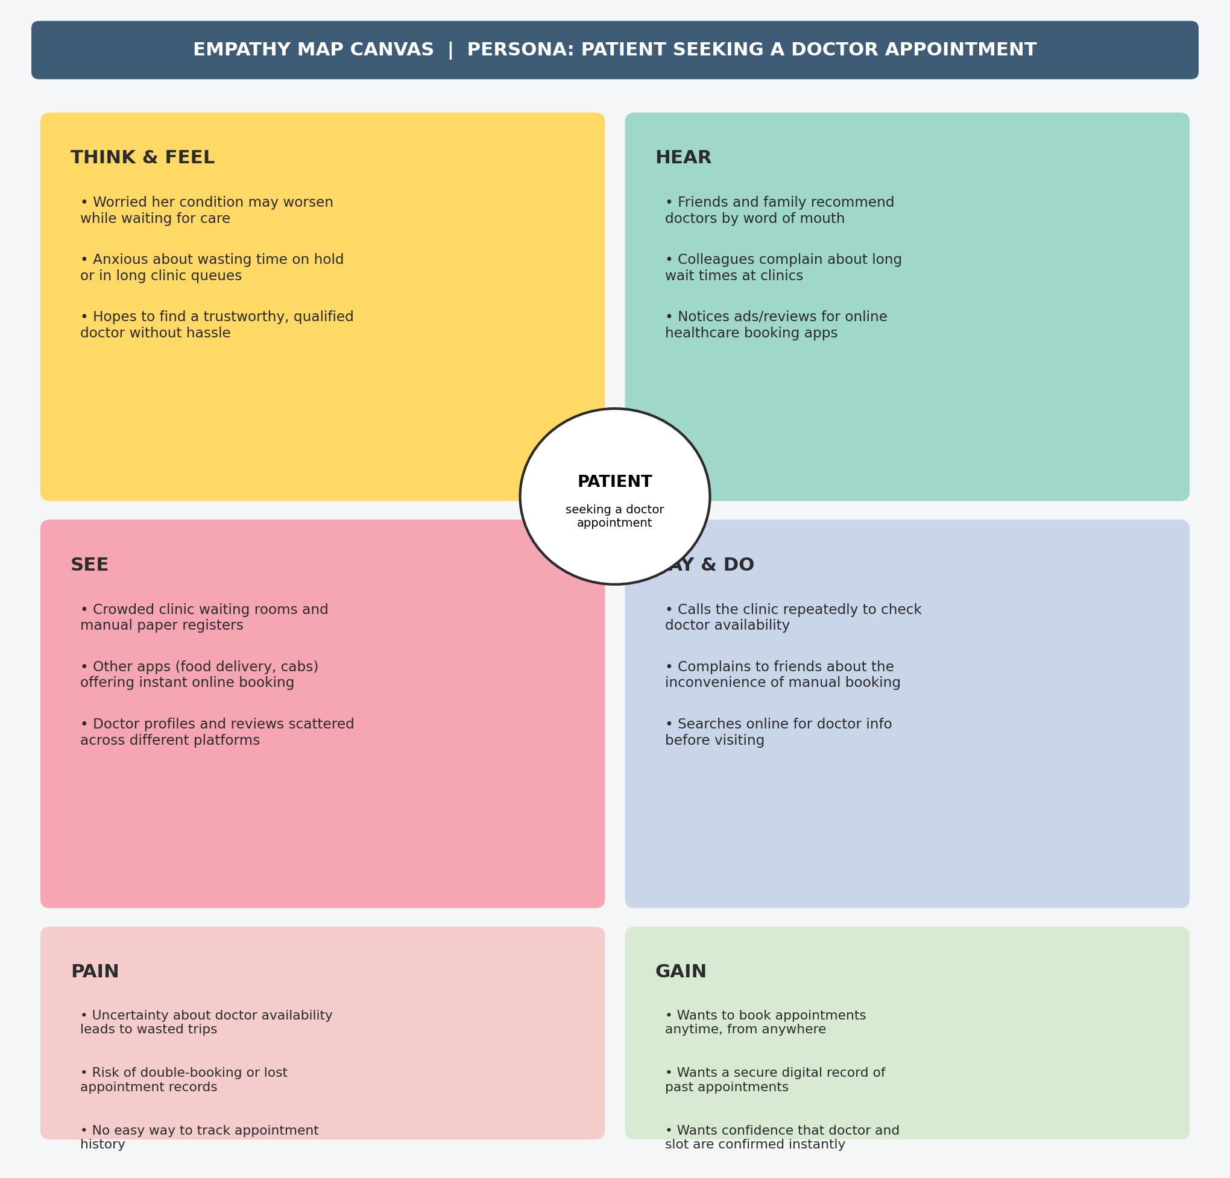

Key Takeaways
The patient's core frustration is uncertainty: not knowing doctor availability, and not having a reliable digital trail of appointments. This directly validates the proposed system's focus on real-time booking, appointment history, and confirmed scheduling — the same needs would apply, with adapted context, to the Doctor and Administrator personas.

